University Economic Development Association – 2022 Summit
2022 Call for Workshops & Presentations

Deadline: June 1, 2022

Planning is now underway to identify topics and presenters for concurrent sessions at the 2022 UEDA Summit.

Many of us have heard that the one thing that’s constant in life is change. The past couple of years have been full of change, good and bad. While the economy is looking strong, we’re still facing trouble with supply chains, labor, and an ever-changing pandemic. The UEDA 2022 Summit will explore how we as practitioners can harness innovations in our institutions of higher education to help our ecosystems realize and capitalize on potential new opportunies. We’ll work together to discuss potential threats, like energy shortages and cyberattacks, and how we can pivot to transition these to new potential industries and jobs.

The 2022 Summit theme is
“Harnessing Your Region’s Energy to Accelerate Innovative Futures”

As UEDA’s Foundations for Strategy and Practice study has shown (http://Foundations.UniversityEDA.org) the three major areas of innovation, talent and place drive change. In partnership with Virginia Tech and funded by the Economic Development Administration (EDA), UEDA is also developing networks focused on addressing economic resiliency and equity as well as convening EDA University Centers to advance regions. Universities play a significant role in this development and the 2022 Summit will also highlight these activities, especially as they relate to our theme. We seek topics and activities which align with these areas for our Summit.

Sessions must relate to the summit theme and provide a true learning opportunity for participants. The only exception to this are the Lightning Rounds. While we are planning for an in-person event, in the event that the Summit needs to shift to a virtual format again this year, all proposals should include a plan to adapt the proposed session to a virtual format.

In the spirit of collaboration within an ecosystem, proposals that include university economic development partners are encouraged (City. Chamber of Commerce, State, Industry, etc…).

Presentations from past Summits are archived on the UEDA website.

Presentation Topics
Topics for the summit should address the main theme and subtopics which are the same as the Awards of Excellence categories and based on our Foundations doctrine. Topics should address the concept of innovation, talent, or place or any combination of the three with a regional impact. For more information regarding the topics, visit Foundations.UniversityEDA.org.

At previous Summits, we asked participants what they would like to learn at future Summits. The word cloud below represents a hierarchy of topics they indicated as areas of interest:

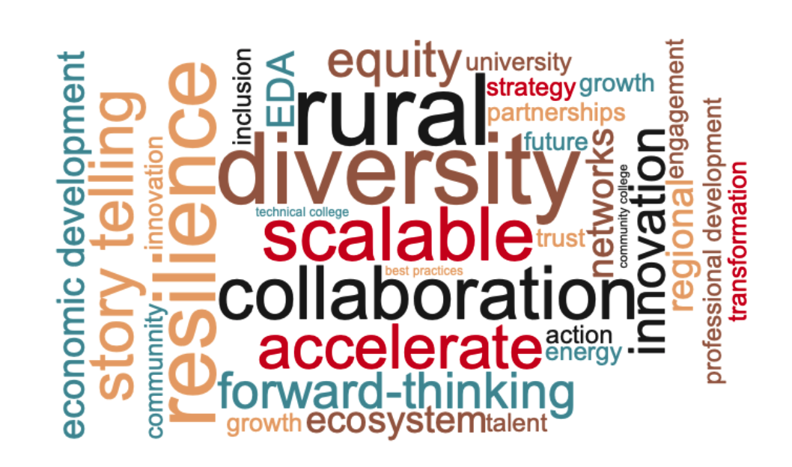

Summit Audience
All presentations should consider the positions of those attending the Summit:

- College and University Presidents
- Provosts, Deans & Outreach Officers
- EDA Center Directors
- External & Government Affairs Administrators
- Innovation, Commercialization & Technology Transfer Directors
- Officials from Higher Education System Offices
- Economic Developers
- Economic Development Consultants
- Market Development Specialists
- Federal Agency Program Directors
- State and Federal Grant Administrators
- Manufacturing Extension Partnership Directors & Managers
- Workforce Development Directors
- University and College Faculty
- Graduate-level Student Economic Development Professionals
- University-Industry Liaisons

Types of Presentations
UEDA is seeking diverse and unique presentation styles to fill concurrent session spots. Workshops, roundtables, interactive activities, etc. are all encouraged – the more engaging the better! Preference will be given to sessions that encourage audience participation and engagement. Each session will generally be about one hour and fifteen minutes in length and should include time for Q&A, as well as a small amount of time at the beginning and end of the session for participants to arrive/depart. Electronic presentations, PowerPoints, videos, etc. are welcome, however, speaker bio/presentation deadlines must be adhered to in order to ensure appropriate publication deadlines can be met. Innovative and creative sessions topics and styles are strongly encouraged.

Panel Discussion
Typically, for panel discussion sessions there is a session moderator and 2-3 panelists. Specialty needs (e.g. presentation audio/video, etc.) should be identified up front. Again, this type of presentation is permitted with elements of audience engagement beyond the Q&A period.

Workshop
Workshop sessions at the Summit should include an introductory portion for presenters to introduce their presentation, followed by a more interactive and intensive group discussion surrounding the topic presented. Specialty needs (e.g. presentation audio/video, etc.) should be identified up front.

Experiential Learning
Experiential learning is a process through which participants develop knowledge, skills, and values from direct experiences outside the traditional conference setting. While Summit schedule is very tight, we welcome new ways to challenge the traditional conference environment.

Lightning Round
The UEDA Lightning Round provides best practices around a single broad topic in a quick, lightning-round format. Each presenter will have five minutes to present their idea in a quick, engaging, and inspirational way while using limited presentation materials. Immediately following the presentations, a question and comment session with the audience will take place for all presenters.

The topic, “Harnessing Your Region’s Energy to Accelerate Innovative Futures” is intentionally broad. The Lightning Round relies on each presenters’ interpretation of the topic and ideas and initiatives being generated in their regions. Presentations can be highlighting an existing program or initiative, a conceptual idea, or research around the topic.

Review Criteria
UEDA’s Summit committee will review all proposals and will recommend submissions based on content (clarity of purpose and appropriateness to the topic and audience); relevance (alignment of proposal to conference theme); and balance (diversity of topics against other proposals). The agenda committee may work with session leaders to refine topics and ideas or potentially combine similar session proposals.

W O R K S H E E T
2022 Call for Workshops & Presentations

The worksheet below is meant to be completed by the submission team. After completing this sheet, please visit the Summit Application Portal and copy/past your responses into the submission form. You will also be asked to upload presenter information, including bio and photo. If you do not have all presenters solidified, please upload what you can in order to keep your application active.

The UEDA Summit committee will review and rank all submissions and notify all applicants by July 1, 2022 the status of their proposal. All presentations will be conducted at the UEDA Summit in San Antonio, TX October 9 – October 12, 2022. Panelists and moderators will be notified of the final presentation time and day by August 31, 2022.

Topic Areas:

Please rank your submission’s amount of content in the following areas:

Talent
1 2 3 4 5 6 7 8 9 10
Less More

Innovation
1 2 3 4 5 6 7 8 9 10
Less More

Place
1 2 3 4 5 6 7 8 9 10
Less More

Other (Specify: )

Contact Information of Submitter

Name of Primary Contact:
Title:
Organization/Institution:
Address:
City, State, Zip:
Phone:
Email:

Comments/Notes:

SUMMIT PRESENTATION

Presentation Format
Is your presentation a:

0 Panel Discussion
0 Workshop 0 Experiential Learning
0 Other (Describe: )

Awards of Excellence Participation:
Are you also planning to nominate your project for a 2022 UEDA Award of Excellence?

0 Yes
0 No

Presentation Information

Title of Presentation:

Abstract of Proposed Session
Limited to 100 words. To be used in the Summit program or on the UEDA website.

What will make this presentation unique?
Limited to 100 words.

What is the relevance of this presentation to UEDA members?
Limited to 100 words.

What is the relevance of this presentation to the Summit Theme?
Limited to 100 words.

Presentation Content
Limited to 1,000 words. Include brief description of the overall presentation and/or a description of each panelist’s presentation.

Presenter Information
Please include name, title, organization, brief bio, phone number, and email address for each presenter.

LIGHTNING ROUND PRESENTATION

Presentation title:

Presentation abstract:
Limited to 100 words.

How does this presentation relate to the Lightning Round Topic? Limited to 100 words.

Awards of Excellence Participation:
Are you also planning to nominate this topic for a 2022 UEDA Award of Excellence?

0 Yes
0 No

