University Economic Development Association – Summit 2020
2020 Call for Content
Deadline: July 1, 2020

Planning is now underway to identify topics and presenters for concurrent sessions at the UEDA Summit 2020.

Economic recovery is imperative. We must not only consider regional recovery but establishing resiliency for long-term survival in an ever-changing world. To accomplish this, UEDA is pleased to host a Virtual Economic Accelerator Summit assembling economic development minds from across the globe to collaborate and co-design strategies to leverage higher education institutions to advance economic acceleration and resiliency.
During this one-of-a-kind Summit, participants will collaborate on regional challenges, hear from industry and higher education experts, and actively participate in digital workspaces, design-thinking sessions, and visual collaborations to develop a framework for accelerating regional economies. This is NOT your typical online conference. This will be an immersive, engaging experience where participants will work collaboratively across digital channels to share ideas, data, and expertise to develop actionable take-aways. All economic development minds and allies are encouraged to attend.

The 2020 Summit theme is “Redesigning the Future Amidst Dynamic Change: A Virtual Economic Accelerator Summit”

Also, as UEDA’s Foundations for Strategy and Practice study has shown the three major areas of talent, innovation, and place, drive change. Universities play a significant role in this development and the 2020 Summit will highlight these activities. We seek topics and activities which align with these areas for our Summit.

The Summit committee strongly encourages session proposals to integrate a variety of formats. While panels are welcome, we prefer engagement and audience participation as much as possible. Workshops, design thinking sessions, and sessions where participants are active will be evaluated as more favorable.

In the spirit of collaboration within an ecosystem, proposals that include university economic development partners are encouraged (City, Chamber of Commerce, State, Industry, etc).
Presentation Topics
Topics for the Summit should address the main theme and subtopics (which are the same as the Awards of Excellence categories) and based on our Foundations doctrine. Topics should address the concept of talent, innovation, or place or any combination of the three with a regional impact. For more information regarding the topics, visit Foundations.UniversityEDA.org.

At the 2019 Summit, we asked participants what they would like to learn from the 2020 Summit. The word cloud below represents a hierarchy of topics they indicated as areas of interest:

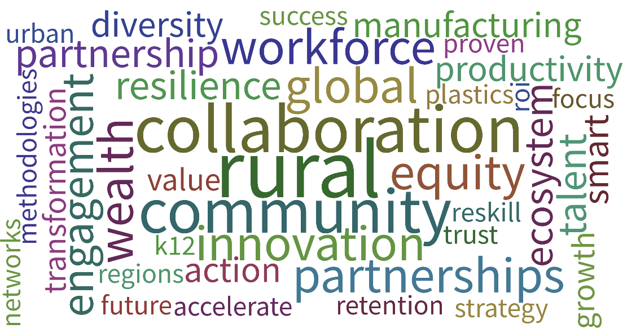

Summit Audience
All presentations should consider the positions of those attending the Summit:

- College and University Presidents
- Provosts, Deans & Outreach Officers
- EDA Center Directors
- External & Government Affairs Administrators
- Innovation, Commercialization & Technology Transfer Directors
- Officials from Higher Education System Offices
- Economic Developers
- Economic Development Consultants
- Market Development Specialists
- Federal Agency Program Directors
- State and Federal Grant Administrators
- Manufacturing Extension Partnership Directors & Managers
- Workforce Development Directors
- University and College Faculty
- Graduate-level Student Economic Development Professionals
- University-Industry Liaisons?

Types of Content
UEDA is seeking diverse and unique presentation styles to fill concurrent session spots. Workshops, roundtables, interactive activities, etc. are all encouraged – the more engaging the better! Preference will be given to sessions that encourage audience participation and engagement. Each session will generally be about one hour and fifteen minutes in length and should include time for Q&A, as well as a small amount of time at the beginning and end of the session for participants to arrive/depart. Electronic presentations, PowerPoints, videos, etc. are welcome, however, speaker bio/presentation deadlines must be adhered to in order to ensure appropriate publication deadlines can be met. Innovative and creative sessions topics and styles are strongly encouraged.

Panel Discussion
Typically, for panel discussion sessions there is a session moderator and 2-3 panelists. Specialty needs (e.g. presentation audio/video, etc.) should be identified up front. Again, this type of presentation is permitted with elements of audience engagement beyond the Q&A period.

Workshop
Workshop sessions at the Summit should include an introductory portion for presenters to introduce their presentation, followed by a more interactive and intensive group discussion surrounding the topic presented. Specialty needs (e.g. presentation audio/video, etc.) should be identified up front.

Experiential Learning
Experiential learning is a process through which participants develop knowledge, skills, and values from direct experiences outside the traditional conference setting. While Summit schedule is very tight, we welcome new ways to challenge the traditional conference environment.

Review Criteria
UEDA’s Summit committee will review all proposals and will recommend submissions based on content (clarity of purpose and appropriateness to the topic and audience); relevance (alignment of proposal to conference theme); and balance (diversity of topics against other proposals). The agenda committee may work with session leaders to refine topics and ideas or potentially combine similar session proposals.

W O R K S H E E T
2020 Call for Content

The worksheet below is meant to assist submission teams in preparing their proposals. After completing this sheet, please visit http://bit.ly/UEDAPortal2020 and copy/paste your responses into the submission form. Email Submissions will not be accepted. All submissions MUST be made through the portal. You will also be asked to upload presenter information, including bios and photos. If you do not have all presenters solidified, please upload what you can in order to keep your application active.

The UEDA Summit committee will review and rank all submissions and notify all applicants in early June on the status of their proposal. All presentations will be conducted at the UEDA Summit Digital Summit on September 21 - September 24, 2020. Panelists and moderators will be notified of the final presentation time and day by August 23, 2020. Summit attendance fees are the responsibility of the presenter(s).

GENERAL INFORMATION

Topic Areas:

Please rank your submission’s amount of content in the following areas:

Talent
1 2 3 4 5 6 7 8 9 10
Less More

Innovation
1 2 3 4 5 6 7 8 9 10
Less More

Place
1 2 3 4 5 6 7 8 9 10
Less More

Other (Specify: )

Contact Information of Submitter

Name of Primary Contact:
Title:
Organization/Institution:
Address:
City, State, Zip:
Phone:
Email:

Comments/Notes:

SUMMIT PRESENTATION

Presentation Format
Is your presentation a…

 Panel Discussion
 Workshop
 Experiential Learning
 Other (Describe: )

Awards of Excellence Participation:
Are you also planning to nominate your project for a 2020 UEDA Award of Excellence?

 Yes
 No

Presentation Information
Title of Presentation:

Abstract of Proposed Session:
Limited to 100 words. To be used in the Summit program or on the UEDA website.

What will make this presentation unique?
Limited to 100 words.

What is the relevance of this presentation to UEDA members?
Limited to 100 words.

What is the relevance of this presentation to the Summit Theme?
Limited to 100 words.

Presentation Content
Limited to 1,000 words. Include brief description of the overall presentation and/or a description of each panelist’s presentation.

