University Economic Development Association – 2019 Summit
2019 Call for Workshops & Presentations

Deadline: June 15, 2019

Planning is now underway to identify topics and presenters for concurrent sessions at the 2019 UEDA Summit.

Resilience is emerging as a concept and a practice to help individuals, communities, cities, and regions not only withstand chronic and acute shocks but to emerge from them stronger and in a better place. The idea of resilience is often deeply ingrained in individuals and their families and in immediate communities. However, scaling up resilient practices to ensure that an entire region can respond, recover, and grow from systemic shocks is relatively new. Moreover, while many communities have a variety of plans around disaster recovery, economic development, and social services, many have not fully and successfully integrated colleges and universities and their numerous programs addressing resilience issues (e.g., sustainability, economics, health, etc.). By focusing on real-world practices and collaborations between higher education institutions and their partners, the 2019 UEDA Summit will explore the topic and highlight manageable, scalable and impactful programs and projects that can be implemented by regions across the globe. Often the biggest little idea can grow to make a catalytic shift.

The 2019 Summit theme is “Designing Resilient Regions: The Biggest Little Ideas for ALL Ecosystems”

Also as UEDA’s Foundations for Strategy and Practice study has shown (http://Foundations.UniversityEDA.org) the three major areas of innovation, talent and place drive change. Universities play a significant role in this development and the 2019 Summit will highlight these activities. We seek topics and activities which align with these areas for our Summit.

The summit committee strongly encourages session proposals to integrate a variety of formats. While panels are welcome, we prefer have engagement and audience participation as much as possible. Workshops, design thinking sessions, and sessions where participants are active will be evaluated as more favorable. The only exception to this are the Lightning Rounds. Sessions must relate to the summit theme and provide a true learning opportunity for participants.

Presentations from past Summits are archived on the UEDA website.

Presentation Topics
Topics for the summit should address the main theme and subtopics which are the same as the Awards of Excellence categories and based on our Foundations doctrine. Topics should address the concept of innovation, talent, or place or any combination of the three with a regional impact. For more information regarding the topics, visit Foundations.UniversityEDA.org.

At the 2018 Summit, we asked participants what they would like to learn from the 2019 Summit. The word cloud below represents a hierarchy of topics they indicated as areas of interest:

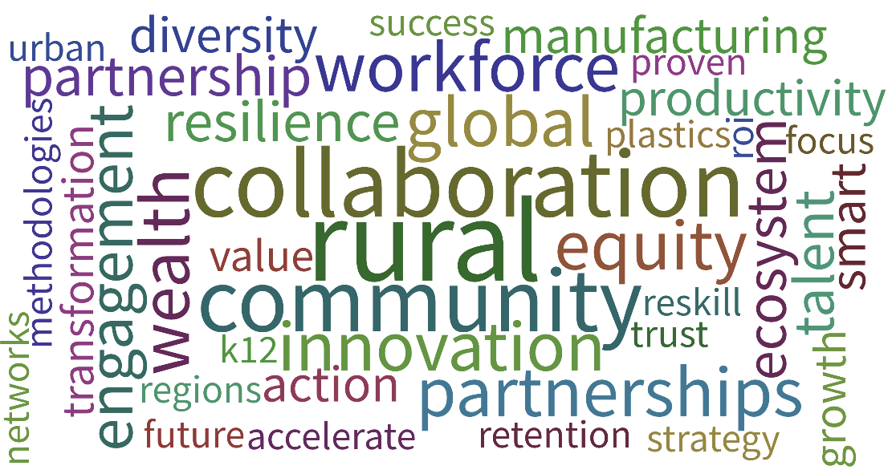

Summit Audience
All presentations should consider the positions of those attending the Summit:

- College and University Presidents
- Provosts, Deans & Outreach Officers
- EDA Center Directors
- External & Government Affairs Administrators
- Innovation, Commercialization & Technology Transfer Directors
- Officials from Higher Education System Offices
- Economic Developers
- Economic Development Consultants
- Market Development Specialists
- Federal Agency Program Directors
- State and Federal Grant Administrators
- Manufacturing Extension Partnership Directors & Managers
- Workforce Development Directors
- University and College Faculty
- Graduate-level Student Economic Development Professionals

Types of Presentations
UEDA is seeking diverse and unique presentation styles to fill concurrent session spots. Workshops, roundtables, interactive activities, etc. are all encouraged – the more engaging the better! Preference will be given to sessions that encourage audience participation and engagement. Each session will generally be about one hour and fifteen minutes in length and should include time for Q&A, as well as a small amount of time at the beginning and end of the session for participants to arrive/depart. Electronic presentations, PowerPoints, videos, etc. are welcome, however, speaker bio/presentation deadlines must be adhered to in order to ensure appropriate publication deadlines can be met. Innovative and creative sessions topics and styles are strongly encouraged.

Panel Discussion
Typically, for panel discussion sessions there is a session moderator and 2-3 panelists. Specialty needs (e.g. presentation audio/video, etc.) should be identified up front. Again, this type of presentation is permitted with elements of audience engagement beyond the Q&A period.

Workshop
Workshop sessions at the Summit should include an introductory portion for presenters to introduce their presentation, followed by a more interactive and intensive group discussion surrounding the topic presented. Specialty needs (e.g. presentation audio/video, etc.) should be identified up front.

Experiential Learning
Experiential learning is a process through which participants develop knowledge, skills, and values from direct experiences outside the traditional conference setting. While Summit schedule is very tight, we welcome new ways to challenge the traditional conference environment.

Lightning Round
The UEDA Lightning Round provides best practices around a single broad topic in a quick, lightning-round format. Each presenter will have five minutes to present their idea in a quick, engaging, and inspirational way while using limited presentation materials. Immediately following the presentations, a question and comment session with the audience will take place for all presenters.

The topic, “Designing Resilient Regions: The Biggest Little Ideas for ALL Ecosystems” is intentionally broad. The Lightning Round relies on each presenters’ interpretation of the topic and ideas and initiatives being generated in their regions. Presentations can be highlighting an existing program or initiative, a conceptual idea, or research around the topic.

Review Criteria
UEDA’s Summit committee will review all proposals and will recommend submissions based on content (clarity of purpose and appropriateness to the topic and audience); relevance (alignment of proposal to conference theme); and balance (diversity of topics against other proposals). The agenda committee may work with session leaders to refine topics and ideas or potentially combine similar session proposals.

W O R K S H E E T
2019 Call for Workshops & Presentations

The worksheet below is meant to be completed by the submission team. After completing this sheet, please visit https://www.surveygizmo.com/s3/4887801/UEDA-2019-Application-Portal and copy/past your responses into the submission form. You will also be asked to upload presenter information, including bio and photo. If you do not have all presenters solidified, please upload what you can in order to keep your application active.

The UEDA Summit committee will review and rank all submissions and notify all applicants by July 1, 2019 the status of their proposal. All presentations will be conducted at the UEDA Summit in Reno, Nevada September 29-Ocotober 1, 2019. Panelists and moderators will be notified of the final presentation time and day by September 1, 2019.

Topic Areas:

Please rank your submission’s amount of content in the following areas:

Talent
1 2 3 4 5 6 7 8 9 10
Less More

Innovation
1 2 3 4 5 6 7 8 9 10
Less More

Place
1 2 3 4 5 6 7 8 9 10
Less More

Other (Specify: )

Contact Information of Submitter

Name of Primary Contact:
Title:
Organization/Institution:
Address:
City, State, Zip:
Phone:
Email:

Comments/Notes:

SUMMIT PRESENTATION

Presentation Format
Is your presentation a:

0 Panel Discussion
0 Workshop 0 Experiential Learning
0 Other (Describe: )

Awards of Excellence Participation:
Are you also planning to nominate your project for a 2019 UEDA Award of Excellence?

0 Yes
0 No

Presentation Information

Title of Presentation:

Abstract of Proposed Session
Limited to 100 words. To be used in the Summit program or on the UEDA website.

What will make this presentation unique?
Limited to 100 words.

What is the relevance of this presentation to UEDA members?
Limited to 100 words.

What is the relevance of this presentation to the Summit Theme?
Limited to 100 words.

Presentation Content
Limited to 1,000 words. Include brief description of the overall presentation and/or a description of each panelist’s presentation.

Presenter Information
Please include name, title, organization, brief bio, phone number, and email address for each presenter.

LIGHTNING ROUND PRESENTATION

Presentation title:

Presentation abstract:
Limited to 100 words.

How does this presentation relate to the Lightning Round Topic? Limited to 100 words.

Awards of Excellence Participation:
Are you also planning to nominate this topic for a 2019 UEDA Award of Excellence?

0 Yes
0 No

